# ExcelDataRefresh tool

Uses Microsoft Excel 15.0 Object Library assembly for Excel manipulation.

This tool can refresh all data connections in an Excel file on a SharePoint site, local file or a file in network shared folder. You need to make sure that the user running the tool has required (Edit, Check-in/out) permissions on the file.

This tool can be scheduled using windows task scheduler or SQL Server Agent Job.

Microsoft Office should be installed on the machine this tools runs. Current version is developed and tested on a machine with Microsoft Office 2013 installed.

## How to schedule the ‘ExcelDataRefresh’ tool?

1. Copy the ‘ExcelDataRefresh.exe’ to required folder.
2. Create Task in windows Task scheduler.
3. Fill all the task properties as required.
4. Below are the common security options used for scheduling. For this the user must be in admin group and it is better to run the task with highest privileges.

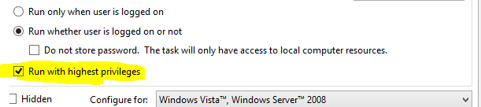

1. Use below screenshot to complete ‘Actions’ tab

Enter exe path in the Program/script property. Enter the absolute path of the Excel file as argument to the exe.

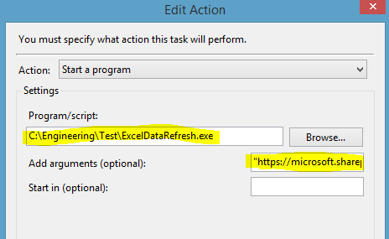

1. Note that if there are spaces in the folder/directory names of the exe path or Excel file name path enclose the path in the double quotes.

## Troubleshooting Tips:

1. When this tool is scheduled using windows scheduler you may observe below error:

Error: Microsoft Excel cannot access the file <<filename>>. There are several possible reasons:

* The file name or path does not exist.
* The file is being used by another program.
* The workbook you are trying to save has the same name as a currently open workbook.

**Resolution:** Verify if user has required permissions or not. If user has permissions and still this error is observed, creating below folders based on the Excel version installed on the machine seems to be solving the issue.

* c:\windows\system32\config\systemprofile\desktop
* c:\windows\syswow64\config\systemprofile\desktop

1. If you observe unhandled exceptions like

Retrieving the COM class factory for component with CLSID {00024500-0000-0000-C000-000000000046} failed due to the following error: 80080005 Server execution failed (Exception from HRESULT: 0x80080005 (CO_E_SERVER_EXEC_FAILURE)).

OR

Exception Info: System.Runtime.InteropServices.COMException

Stack:

at System.RuntimeTypeHandle.CreateInstance(System.RuntimeType, Boolean, Boolean, Boolean ByRef, System.RuntimeMethodHandleInternal ByRef, Boolean ByRef)

at System.RuntimeType.CreateInstanceSlow(Boolean, Boolean, Boolean, System.Threading.StackCrawlMark ByRef)

at System.RuntimeType.CreateInstanceDefaultCtor(Boolean, Boolean, Boolean, System.Threading.StackCrawlMark ByRef)

at System.Activator.CreateInstance(System.Type, Boolean)

at System.Activator.CreateInstance(System.Type)

at ExcelDataRefresh.Program.Main(System.String[])

**Resolution:** There might be Excel Application instances and hence the tool cannot create new instances. You can find the instances in Task Manager->All User Processes. Once you kill all the Excel instances the tool should run fine.

1. File cannot be accessed or file not found errors may occur if file path/URL is not properly formatted. The tool does required encoding for local paths and URLs but try to see if any of the special characters in the URL are causing the error by testing the tool using a file at different location.